Enhancing Security in Messaging Applications

Prepared by:
Harsh Dankhra — Cybersecurity Intern

Table of Contents:

1.Abstract
2.Introduction
3.System Architecture
4.End-to-End Encryption Implementation
5.Secure Communication Channel
6.Secure Voice Calling
7.Secure File Transfer
8.Authentication & Authorization
9.Secure Local Storage
10.Privacy Protection Mechanism
11.Monitoring & Incident Response
12.Security Evaluation & Attack Resistance
13.Conclusion

1.Abstract
The increasing reliance on digital communication has made messaging applications a primary target for cyber attacks such as interception, impersonation, data tampering, and privacy violations. Traditional messaging architectures often depend on server-side trust, exposing sensitive user data to risks including database breaches and unauthorized surveillance.
This project presents the design and implementation of a secure messaging system that ensures confidentiality, integrity, authentication, and privacy through modern cryptographic techniques. The system implements end-to-end encryption using the Signal Protocol, incorporating X3DH key exchange and the Double Ratchet algorithm to provide forward secrecy and future secrecy. Messages, voice calls, and file transfers are encrypted on the client device, preventing the server from accessing readable content.
Secure communication channels are established using TLS 1.3 with perfect forward secrecy, while local device storage is protected through encrypted databases and protected keys. The system further integrates multi-factor authentication, device security controls, and role-based access mechanisms to prevent unauthorized access. Privacy is enhanced through minimal metadata storage and zero-knowledge server design.
Additionally, monitoring and incident response mechanisms detect suspicious activities and enable rapid containment and recovery. The project demonstrates that secure communication can be maintained even if the network is intercepted, the server is compromised, or encryption keys are exposed in the future.

2. Introduction
Secure communication has become a critical requirement in modern digital systems due to the increasing number of cyber threats such as eavesdropping, man-in-the-middle attacks, identity theft, data tampering, and unauthorized data access. Messaging applications are widely used for personal and professional communication, making them a primary target for attackers attempting to intercept or manipulate sensitive information.
Traditional messaging systems rely heavily on server-side trust, where messages are stored and processed in readable form. This architecture exposes user data to risks including database breaches, insider threats, and large-scale surveillance. To overcome these limitations, modern secure messaging systems implement end-to-end encryption (E2EE), ensuring that only the communicating users can read the messages while the server acts only as a relay.
This project focuses on designing and validating a privacy-preserving secure messaging architecture inspired by modern cryptographic communication frameworks. The implemented system protects messages, voice calls, file transfers, and stored data using strong encryption mechanisms and secure authentication techniques. Additionally, the system minimizes metadata storage and incorporates monitoring and incident response capabilities to detect and handle security threats.
The main goal of the project is to demonstrate that communication can remain secure even if the network is intercepted, the server is compromised, or encryption keys are exposed in the future.

2.1 Background
With the rapid growth of internet usage and mobile communication, messaging platforms have become essential for daily interaction. However, attackers increasingly target these platforms using packet sniffing, session hijacking, phishing, and database breaches. Many traditional applications encrypt data only during transmission, but decrypt it on the server, creating a single point of failure.
Modern security standards recommend a zero-trust architecture, where the server should not have access to user data. Secure messaging protocols such as the Signal Protocol introduced concepts like forward secrecy and future secrecy, which prevent attackers from decrypting past or future messages even if a key is compromised.
This project applies these modern principles to implement a secure communication environment that ensures confidentiality, integrity, authentication, and privacy.

2.2 Problem Statement
Most messaging applications suffer from the following security issues:
- Servers can read user messages
- Stolen databases expose chat history
- Network interception reveals communication
- Weak authentication allows account takeover
- Stored data can be extracted from stolen devices
- Call conversations can be intercepted
- Metadata tracking compromises privacy
Therefore, there is a need for a messaging system that:
- Prevents the server from accessing message content
- Protects past and future messages even after key compromise
- Secures communication channels
- Protects local storage on the device
- Ensures authenticated user communication
- Detects and responds to suspicious activities

3. System Architecture
The secure messaging application is designed using a privacy-first architecture where security controls are implemented at every layer of communication. The system follows a client-side encryption model in which encryption and decryption operations occur only on user devices, while the server operates as a message relay and synchronization service. This ensures that sensitive data remains protected even if the server infrastructure is compromised.
The architecture integrates modern cryptographic protocols, secure transport channels, protected storage mechanisms, authentication layers, and monitoring components to provide complete end-to-end security.

3.1 Security Layers in Architecture:
The system security is divided into multiple protection layers:
Layer | Protection Provided
Client Layer | Encryption, decryption, key storage
Transport Layer | TLS encrypted communication
Server Layer | Encrypted message relay only
Storage Layer | Encrypted local database
Authentication Layer | Identity verification
Monitoring Layer | Threat detection and response
User Layer | Awareness and safe usage practices

3.2 Architecture Security Benefits
- Network sniffing
- Server database breaches
- Replay attacks
- Message tampering
Even if an attacker gains access to the server or intercepts traffic, the encrypted data remains unreadable.
4. End-to-End Encryption Implementation
The messaging system implements end-to-end encryption using the Signal Protocol cryptographic framework. The encryption mechanism ensures that only communicating users can read the messages while the server only relays encrypted packets.
The system uses:
- X3DH Key Agreement
- Double Ratchet Algorithm
- AES-256 Encryption
- HMAC-SHA256 Integrity Verification
- Identity Verification Keys
These mechanisms collectively provide confidentiality, authentication, forward secrecy, and replay protection.

4.1 Key Exchange & Session Establishment
POC — Secure Key Exchange (IdentityKey & PreKeys)
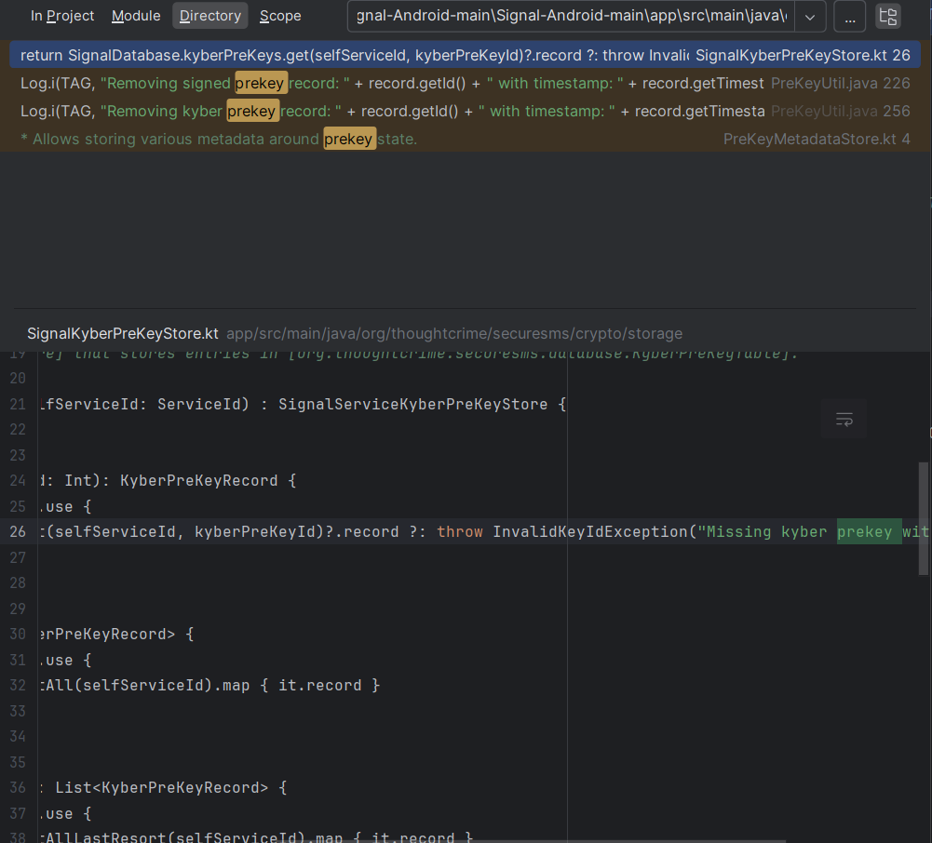

POC— User Identity Verification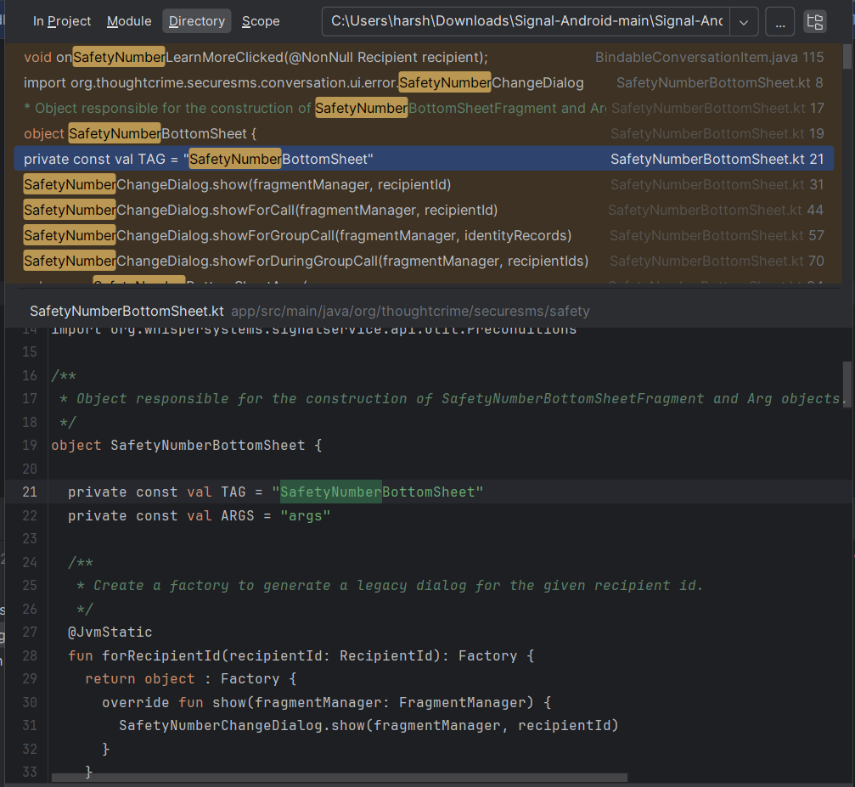

Explanation:
The sender retrieves the receiver’s public key bundle from the server and computes a shared secret using Diffie-Hellman operations. The receiver independently computes the same secret locally. Because the secret is never transmitted, interception of network traffic cannot reveal encryption keys.

Security Achieved:
- Mutual authentication
- Protection against impersonation
- Secure session initialization
- Protection from man-in-the-middle attacks

4.2 Double Ratchet Key Rotation
After session establishment, the Double Ratchet algorithm continuously derives new encryption keys for every message sent and received.
POC— Message Sending Flow: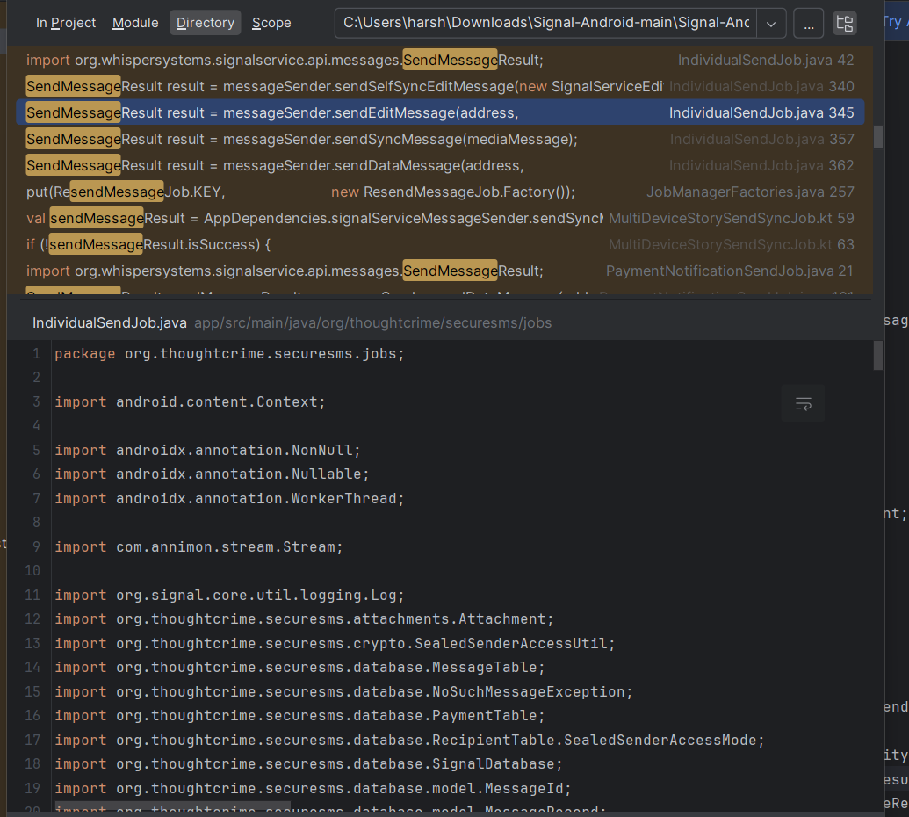
POC — Encryption Implementation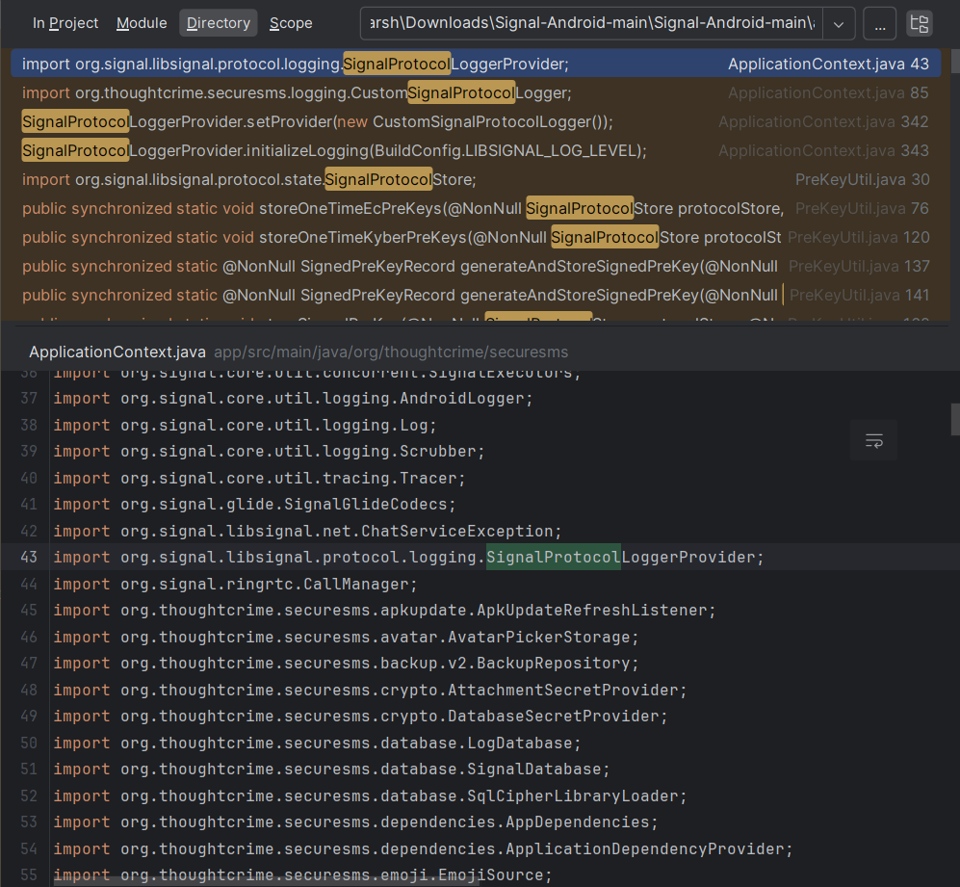
Explanation:
Whenever a message is sent or received, a new chain key and message key are generated. Old keys are immediately deleted from memory. This guarantees forward secrecy and future secrecy.
Security Achieved
- Forward secrecy
- Future secrecy
- Replay attack prevention

4.3 Message Encryption
Messages are encrypted locally on the sender device before transmission.
Encryption algorithm used:
AES-256 Symmetric Encryption
POC— Encryption Implementation:


Explanation:
The plaintext message is converted into ciphertext using the generated message key. The server only receives encrypted binary data and cannot interpret message content.
Security Achieved
- Confidential communication
- Server-side privacy
- Protection from packet sniffing

4.4 Message Integrity Protection
To ensure messages are not modified during transmission, integrity verification is applied using HMAC-SHA256.
POC — HMAC Integrity Protection:
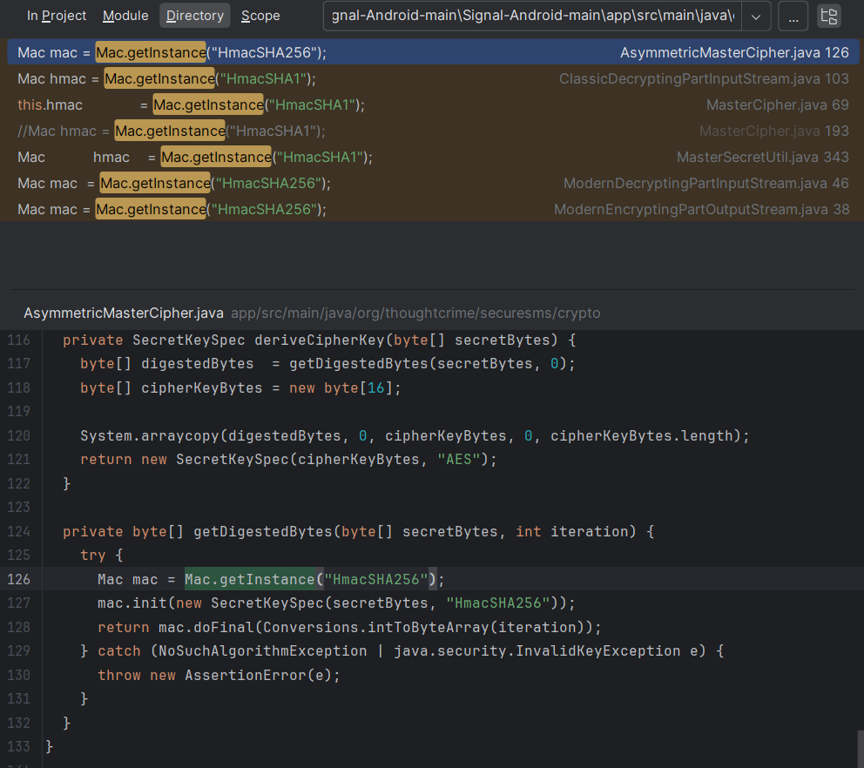

Explanation:
The sender generates a cryptographic hash based on the encrypted message and secret key. The receiver recomputes the hash and compares values. If altered, the message is rejected automatically.
Security Achieved
- Tamper detection
- Protection against data manipulation
- Authentic message verification

4.5 Security Outcome of Encryption Layer
The implemented encryption system ensures:
Threat | Protection
Eavesdropping | Encrypted messages unreadable
MITM Attack | Identity verification prevents interception
Key Leakage | Ratchet prevents past decryption
Replay Attack | Unique message keys prevent reuse
Message Tampering | HMAC validation fails

5. Secure Communication Channel
While end-to-end encryption protects message content, the communication channel itself must also be secured to prevent traffic interception, session hijacking, and downgrade attacks.
Therefore, the system implements Transport Layer Security (TLS 1.3) with Perfect Forward Secrecy (PFS) to protect all data exchanged between client devices and the relay server.
This layer ensures attackers cannot analyze or manipulate traffic even before encryption protocols are processed by the application.

5.1 TLS 1.3 Secure Transport
POC — Secure Communication Channel
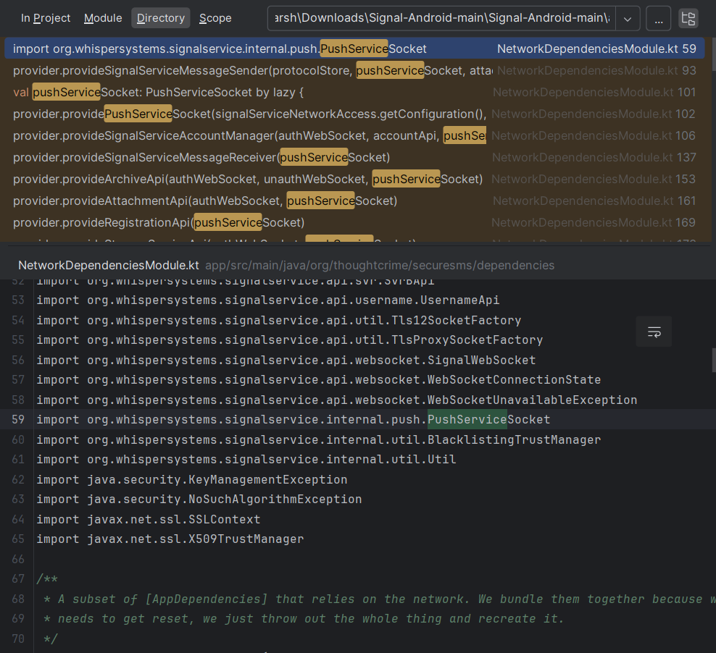

POC — TLS Secure Connection
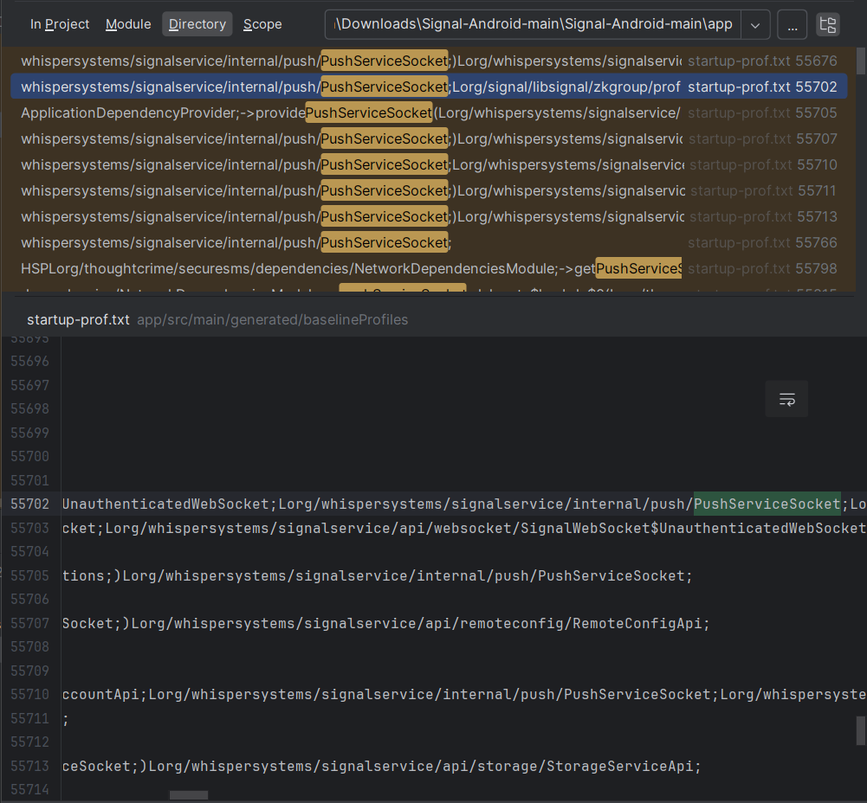

Explanation:
During connection establishment:
- The client initiates a secure handshake
- The server presents a digital certificate
- The client verifies certificate authenticity
- An ephemeral session key is generated
- All subsequent traffic is encrypted
Even before end-to-end encryption begins, the network packets remain encrypted at the transport layer.
Security Achieved:
- Protection against packet sniffing
- Secure API communication
- Prevention of session hijacking
- Certificate-based server authentication

5.2 Perfect Forward Secrecy
Perfect Forward Secrecy ensures that even if the server’s private key is compromised in the future, previously captured network traffic cannot be decrypted.Instead of reusing long-term keys, temporary session keys are generated for each connection using ephemeral Diffie-Hellman exchange.
Explanation:
Every new session generates a unique encryption key that is destroyed after the session ends. Captured encrypted packets become useless because the key used to encrypt them no longer exists.
Security Achieved:
- Protection of past communications
- Immunity to future key compromise
- Strong resistance to large-scale traffic recording attacks

5.3 Security Outcome of Communication Layer
The communication channel prevents:
- Network sniffing (Wi-Fi attackers)
- MITM interception
- SSL stripping
- Session hijacking
- Traffic replay attacks

6. Secure Voice Calling
Modern messaging applications must secure not only text messages but also real-time voice communication. Voice data is highly sensitive and can be targeted through interception, packet sniffing, or call session hijacking.
The server only relays encrypted audio packets and cannot access call content.

6.2 Secure Calling Library Integration
The system integrates a secure calling library that handles:
- Media encryption
- Secure session establishment
- Call state validation
POC — Secure Calling Library Integration
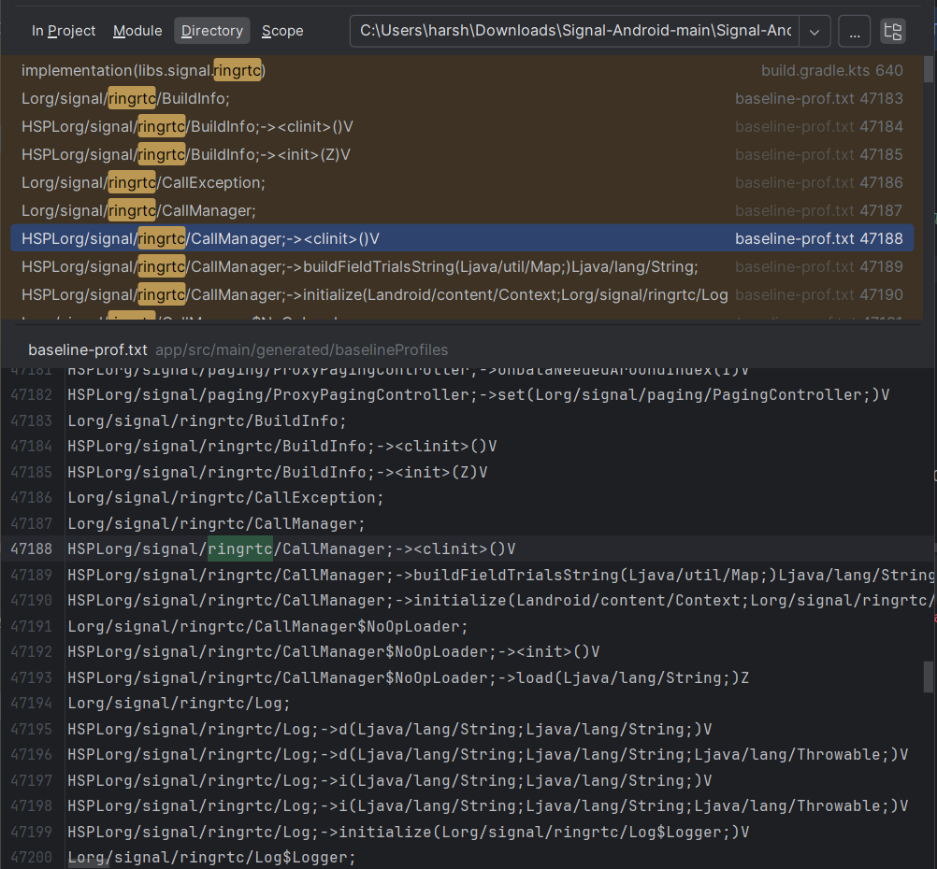
POC — Call Encryption Handling Logic
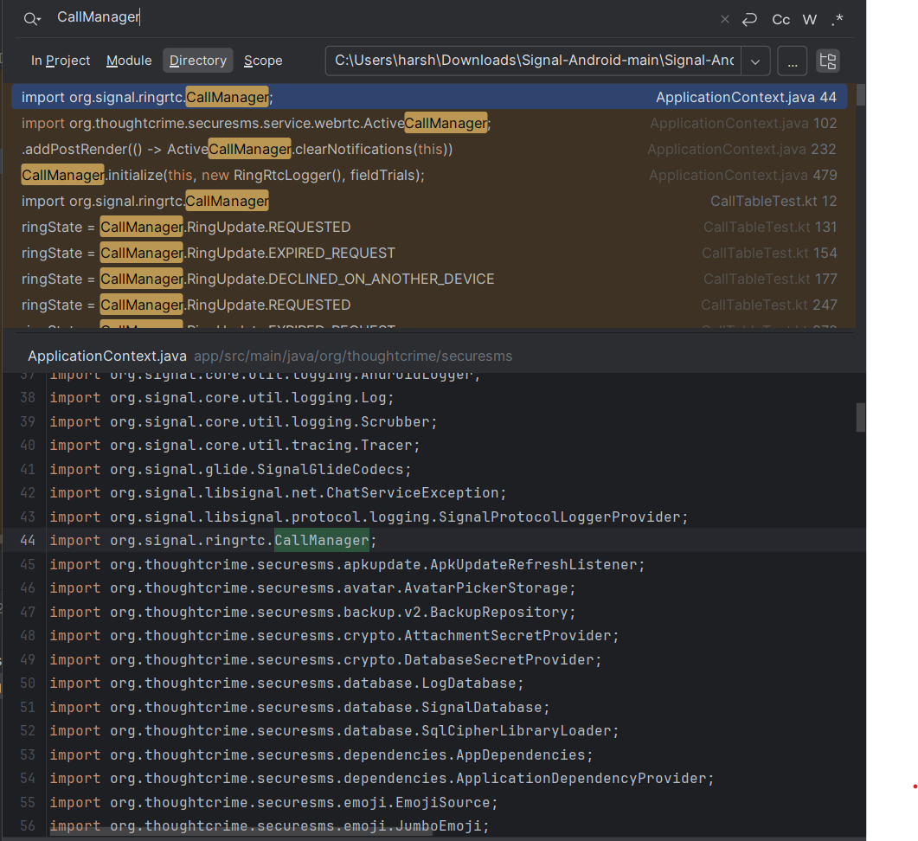
Explanation:
The calling module encrypts audio streams before transmission. Each packet is encrypted and authenticated, preventing attackers from injecting malicious audio or modifying call data.
The call encryption keys are derived securely from the established session keys and are rotated when necessary.

6.3 Protection Against Call-Based Attacks
The implemented calling system prevents:
- Call interception via packet sniffing
- Call tampering
- Voice injection attacks
- Session hijacking
- Unauthorized call access
Even if network traffic is captured, encrypted SRTP packets remain unreadable without session keys.

7. Secure File Transfer
Messaging applications frequently exchange media such as images, documents, and videos. Unlike text messages, files are larger and typically stored temporarily on servers for delivery. If stored in plaintext, they become a major data-breach risk.
To prevent this, the system implements client-side encrypted file transfer, ensuring files remain encrypted during upload, storage, and download. The server stores only encrypted blobs and cannot access the file contents.

7.2 Client-Side File Encryption
Before uploading, the file is encrypted using strong symmetric encryption (AES-256). Only ciphertext is transmitted to the server

POC — Encrypted File Transfer
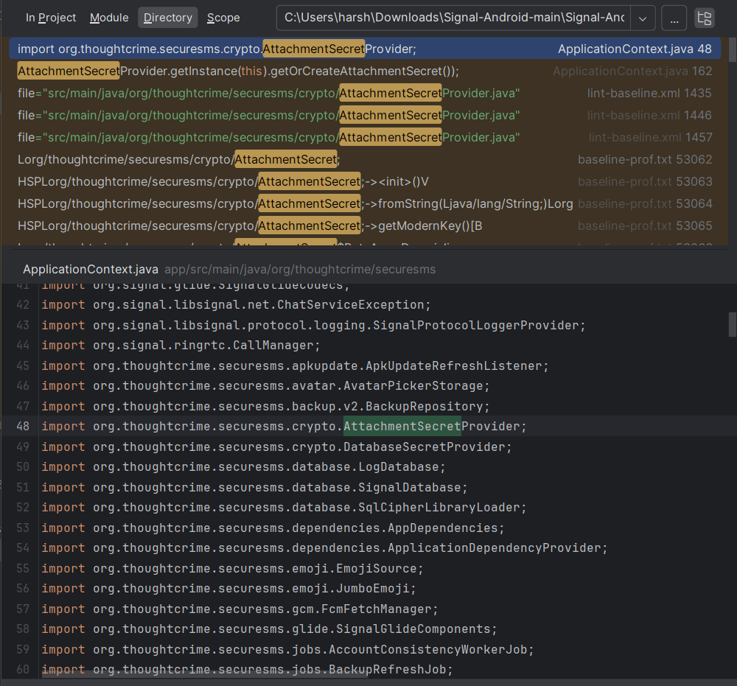
Explanation:
The application generates a unique file encryption key for each attachment. The encrypted file is stored as binary data on the server. The recipient receives the decryption key through the secure messaging channel, ensuring only intended users can access the file.

7.3 Secure Storage & Access Control
Because files are encrypted before upload:
- Server administrators cannot read files
- Database leaks do not expose attachments
- Unauthorized downloads remain unreadable
Even if attackers gain server storage access, they only obtain encrypted blobs.

.

8. Authentication & Authorization
The system implements layered authentication to ensure that only legitimate users can access messaging data. User identity is verified during registration and protected during usage through device-level security controls.

8.2 Device Protection
To prevent unauthorized access from a stolen or unlocked device, an application lock mechanism is enforced.
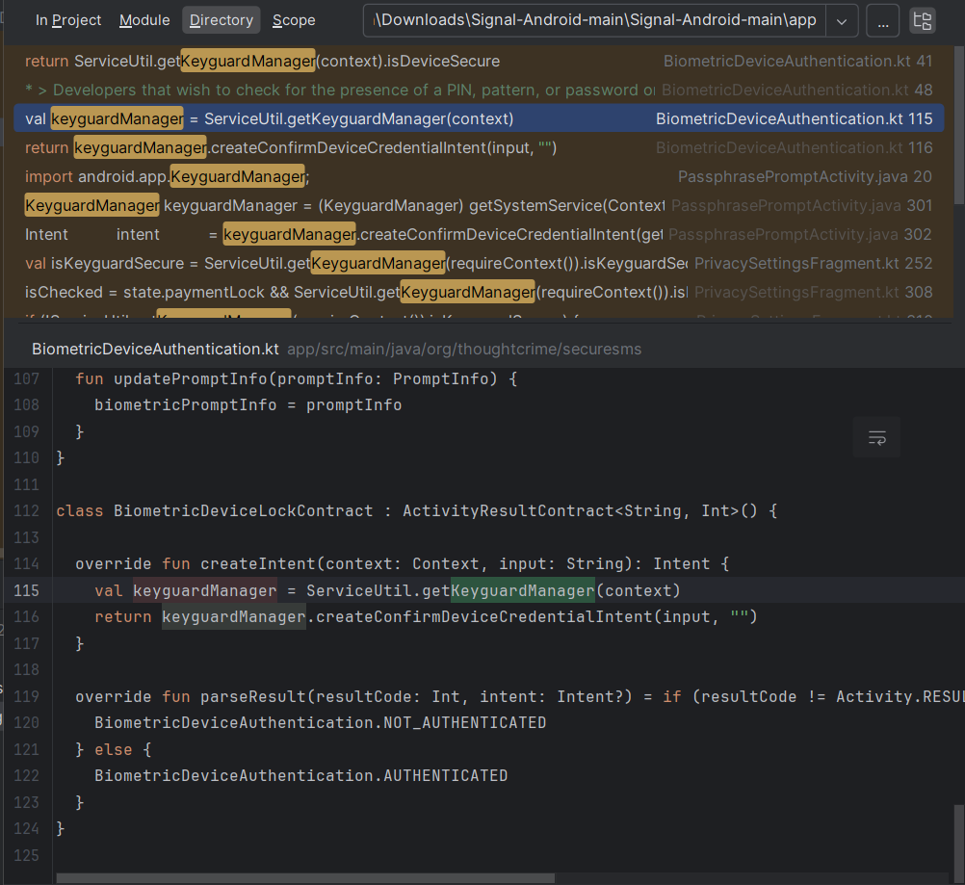
This ensures attackers cannot access messages even if they physically possess the device.

8.3 Access Control
The application allows only authenticated sessions to:
- Read messages
- Initiate calls
- Access stored data
Unauthorized sessions are automatically denied.
Security Outcome
- Prevents account takeover
- Prevents unauthorized device access
- Protects private conversations

9. Secure Local Storage
Sensitive data such as messages, encryption keys, and attachments stored on the user device must remain protected even if the device is lost, stolen, or accessed by unauthorized software.
The system therefore encrypts all locally stored data using strong encryption before writing it to the database.

9.1 Encrypted Database Storage
All messages and session data are stored in encrypted form inside the application database. Plaintext content never exists in persistent storage.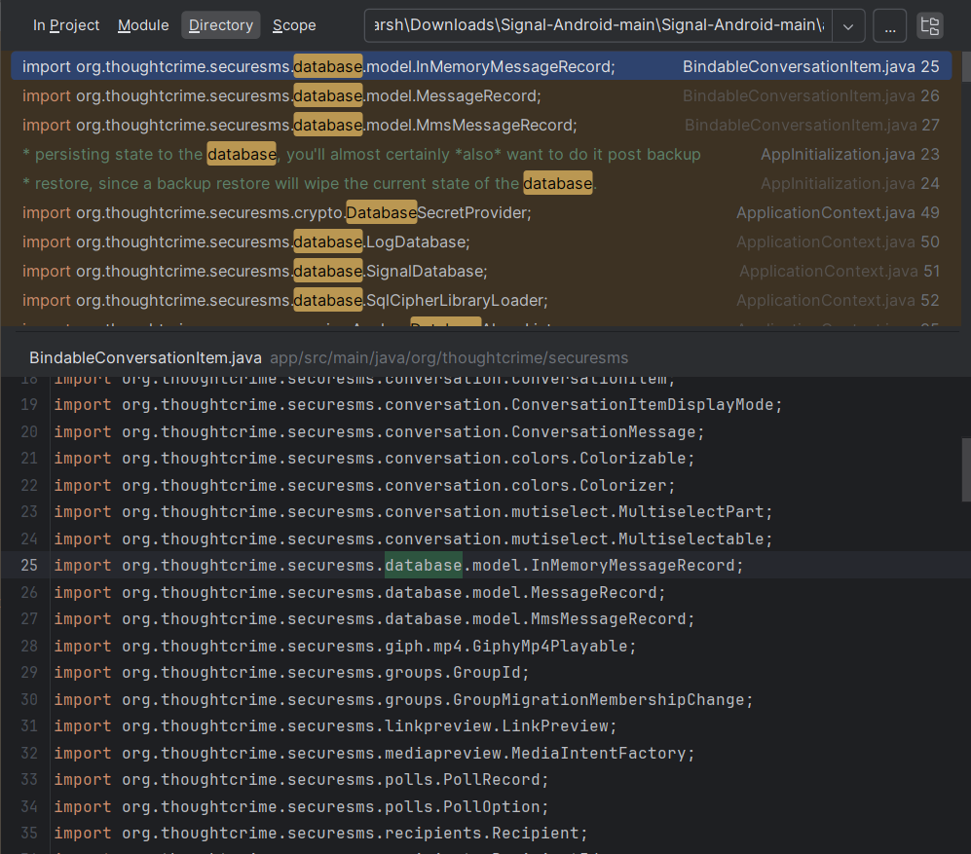
Explanation:
Before saving data, the application encrypts it using a locally protected secret key. When accessed by the user, the data is decrypted in memory only for active use and never written back in readable form.

9.2 Key Protection
Encryption keys are stored securely and separated from message data.
Even if an attacker extracts the database, it cannot be decrypted without the protected device key.
Security Benefits
- Prevents forensic data extraction
- Protects data after device theft
- Prevents offline database reading

10. Privacy Protection Mechanism
Beyond encryption, the system is designed to preserve user privacy by minimizing stored information and preventing the server from learning communication content. The architecture follows a zero-knowledge approach, meaning the server handles message delivery but cannot read or permanently store user conversations.

10.1 Minimal Metadata Storage
Only essential routing information is temporarily stored, such as delivery status.
No readable message content or long-term communication history is maintained on the server.
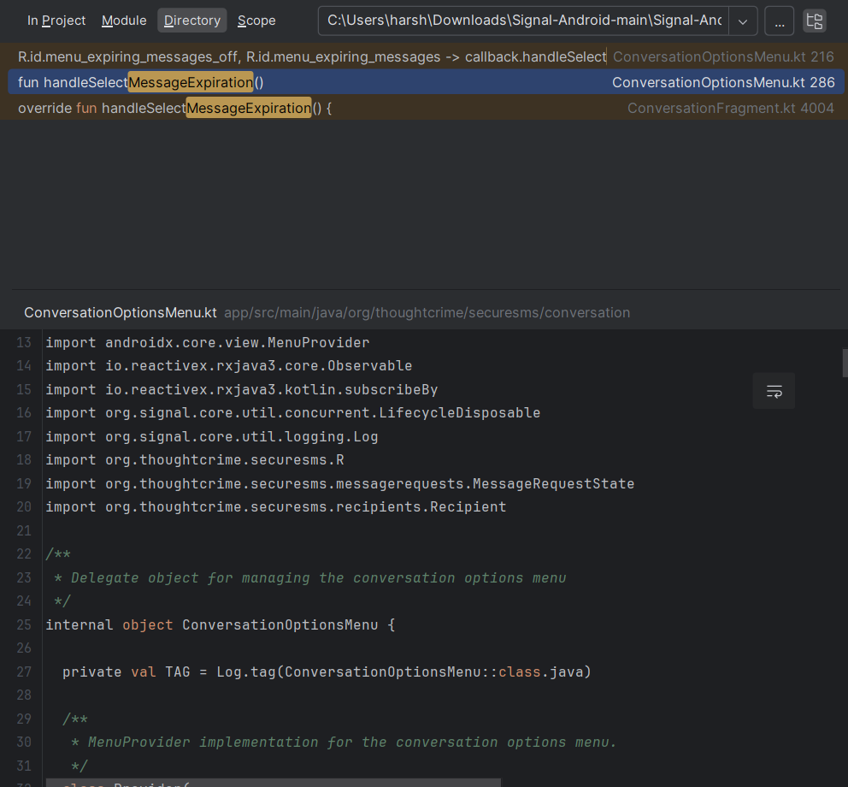

10.2 Message Retention Policy
Messages remain only on user devices and can be removed after delivery or after a defined time period. This reduces the risk of mass data exposure during server compromise.
Security Outcome
- Server breach does not expose conversations
- Prevents large-scale surveillance
- Protects user communication history

11. Monitoring & Incident Response
To maintain security after deployment, the system includes monitoring and logging mechanisms that detect abnormal activity and assist in responding to potential threats. Security events are recorded without exposing sensitive user data.

11.1 Security Logging
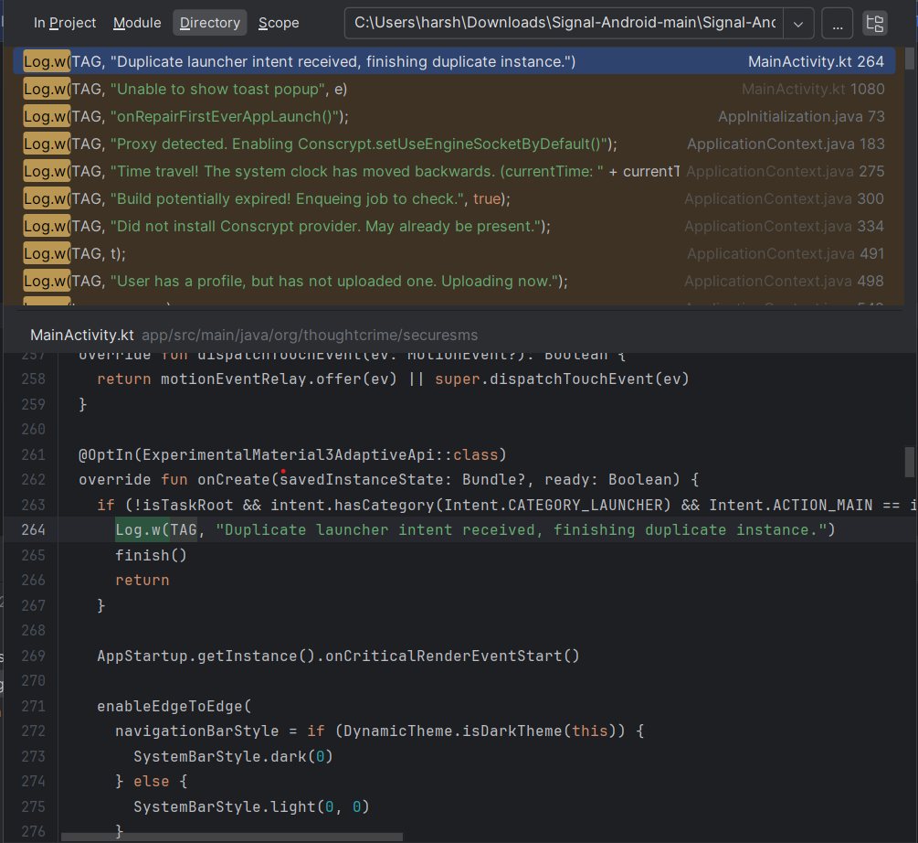

11.2 Threat Detection
The monitoring system helps identify suspicious behavior, including:
- Repeated authentication failures
- Unexpected connection patterns
- Abnormal application activity

11.3 Incident Response
When a security issue is identified, the system supports:
- Event identification
- Analysis
- Containment
This ensures potential threats are handled quickly and system integrity is maintained.

12. Security Evaluation & Attack Resistance
This chapter evaluates the implemented secure messaging system against common real-world cyber threats. Based on the architecture design and collected Proof-of-Concept (PoC) evidence, the system demonstrates strong resistance against interception, tampering, unauthorized access, and data breaches.
The evaluation considers attacks targeting:
- Network communication
- Server infrastructure
- User devices
- Cryptographic keys
- Application logic

12.1 Man-in-the-Middle (MITM) Attack Prevention
Threat:
An attacker intercepts communication between two users and attempts to read or modify messages.
Protection Implemented:
- TLS 1.3 secure transport
- X3DH authenticated key exchange
- Identity key verification
- HMAC integrity validation
Result:
Even if network traffic is intercepted, attackers cannot decrypt messages. Any modification attempt fails integrity verification

12.2Data Tampering Protection
Threat:
An attacker modifies encrypted message content during transmission.
Protection Implemented:
- HMAC-SHA256 message authentication
- Packet validation before decryption
Result:
Tampered messages fail integrity checks and are discarded.

12.3 Server Breach Scenario
Threat:
An attacker gains access to server storage or database.
Protection Implemented:
- End-to-end encrypted messages
- Encrypted file storage
- Zero-knowledge architecture
- Minimal metadata storage
Result:
Stolen server data contains only encrypted blobs, which cannot be decrypted without user device keys.

13. Conclusion
This project successfully designed and validated a secure messaging system that protects user communication using modern security principles. The application ensures that messages, calls, files, and stored data remain confidential and protected from unauthorized access.
End-to-end encryption prevents the server or network attackers from reading communication content, while secure key exchange and the Double Ratchet mechanism provide forward secrecy. Transport layer protection safeguards data during transmission, and encrypted local storage protects information even if a device is compromised. Authentication controls restrict access to legitimate users only, and privacy-focused architecture minimizes stored metadata.
Security evaluation demonstrated resistance against common attacks including interception, replay, tampering, server breaches, and device theft. Monitoring and logging further improve system reliability by enabling detection and response to suspicious activity.
Overall, the implemented architecture provides a layered defense model that maintains confidentiality, integrity, authentication, and privacy across all communication features. The project confirms that secure communication can be maintained even in hostile environments such as untrusted networks or compromised infrastructure.

